Activity 2
Osmosis in Plant Cells-
Materials:

- Potato (one)
- Ruler
- Knife
- Cutting board
- Tape
- Marker
- Two small drinking glasses
- Tap water
- salt
- tap water
- Clock or timer
- Food scale (optional)

The procedure:
1. Make a salt solution by dissolving 2 Tablespoons Salt in 1 cup boiling water. Allow the salt solution to cool to room temperature before proceeding to #2. (It is okay if you cannot measure the Salt or water).
2. Cut two potato strips to be about the same size strips, each approximately 7 cm long, 1.5 cm wide, and 1.0 cm thick. Designate them as "1" and "2".
3. If a food scale is available, weigh each of the strips and record the weights in the designated part of the data table 2. (If not use the data from the accompanying video)
. Using pieces of tape and a maker, identify two small glasses as "1 water" and "2 NaCl", and place each potato strip into the appropriate drinking glass.
5. Fill drinking glass 1 with 1 cup tap water (or enough tap water to submerge the potato strip).
7. Fill drinking glass 2 with the same amount of liquid (as used in drinking glass 1) but use the salt solution (saltwater) prepared in step 1.
6. After approximately four hours, remove the strips and, if possible, reweigh them. Record the weights in the designated part of the appropriate data table 2.
7. Obtain a piece of "fresh" potato for comparison, and observe how the strips look and feel before and after soaking in the solutions. Record your observations in the results sections.

Results:
Table 1: Observations of Potato Slices after treatment with tap Water or Salt Water or no treatment.
Treatment | Observations
Potato strip in Tap Water | The potato cell swells and becomes turgid. Water enters the cell by osmosis, it starts to increase in size, but the cell wall prevents it from bursting. The pressure inside the cell rises until internal pressure equals the external pressure.
Potato strip in Salt Water | The potato cell shrinks and crumples. Water exits the potato cell by osmosis resulting in plasmolysis.
Control Potato strip** | The potato cell remained the same since it was the control experiment.
**a "fresh" potato slice, cut just before you are ready to make your observations about the tap water and saltwater treatments.

Table 2: Weight of potato strips before and after treatment with different tonicity liquids.
Treatment | Initial Weight of Potato Strip (g) | Weight of Potato Strip after 1 hour (g) | The difference in Weight (use +g or -g)
Tap Water
Salt Water

Conclusions:
Briefly explain your results. Be sure to correctly use the following terms: Hyperosmotic, Hypo-osmotic, Hypotonic, Hypertonic, Osmosis, Diffusion, Concentration gradient, and selectively permeable membrane.

Activity 3
Effects of Hypotonic and Hypertonic Solutions on Red Blood Cells
In this exercise, you will observe what happens to red blood cells (RBC) when placed in solutions of varying tonicity. Blood cells are tiny cells, so examples use an oil immersion lens to observe the effects of these solutions.
Hypothesis: The tonicity of a solution affects the water content and structure of red blood cells.

Predictions:
RBC in isotonic solution – In an isotonic solution, red blood cells will not shrink or swell.

RBC in hypertonic solution – Water within the red blood cells will move out via osmosis into the surrounding solution causing the red blood cells to shrink and shrivel.

RBC in hypotonic solution – In a hypotonic solution, the red blood cells will increase in size. The hypotonic solution in which the red blood cells are in will rapidly enter the cell through osmosis, causing the cells to burst (hemolysis).

Observation:
Watch this video of https://www.youtube.com/watch?v=A8cI6FkcG4c. Pause the video at 1:51, 242, and 3:18 to make observations and sketch the cells.
Results:
RBC in isotonic solution (1:51 in 0.9% NaCl @ 1500x) – The red blood cell did not shrink. That is, it remained the same.
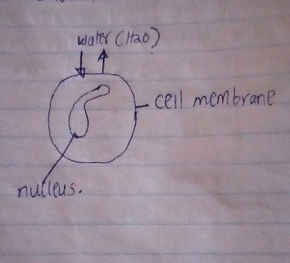

RBC in a hypertonic solution (2:42 in 10% NaCl @1500x) – The red blood cell loses water and becomes deformed and crenated.

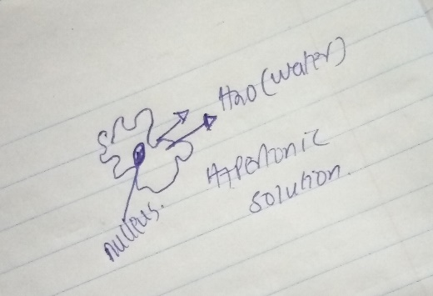
RBC in hypotonic solution (3:18 in water @1500x) – The red blood cells gain water, it swells and then bursts (Hemolysis).
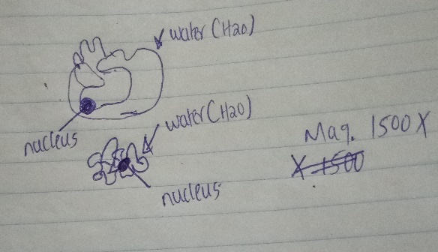

Activity 4
Effects of Hypotonic and Hypertonic Solutions on Plant cells
In this exercise, you will observe what happens to plant cells (elodea) when placed in solutions of varying tonicity.
Hypothesis: The tonicity of a solution affects the water content and structure of plant cells.

Predictions:
PLANT CELL in hypertonic solution – The plant cell loses water, hence turgor pressure by plasmolysis. Pressure decreases to a point where the protoplasm of the cell peals away from the plant cell wall, leaving spaces between the cell wall and the membrane causing the cell to shrink and crumple.

PLANT CELL in hypotonic solution – Water enters the cell by osmosis. The plant cell begins to swell. The cell wall prevents the plant cell from bursting, making it puffy.

Observation:
Watch the video https://youtu.be/zVvHn6Sj9PQ to make observations and sketch the cells.
Results:
PLANT CELL in a hypertonic solution (20% sucrose 0:00-0:23) –
Water exits the plant cell through osmosis, resulting in plasmolysis.

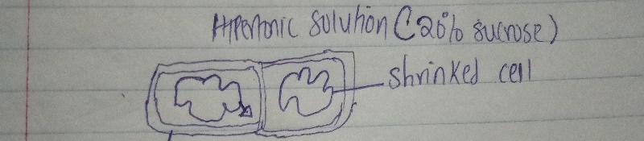

PLANT CELL in hypotonic solution (water 0:24-0:38) another good video of hypotonic is (https://youtu.be/pFsty-XyLZc)- Water enters the cell through osmosis resulting in turgidity of the plant cell
